**Course Project   
DeVry University  
College of Engineering and Information Sciences**

***Screenshot of program running:***

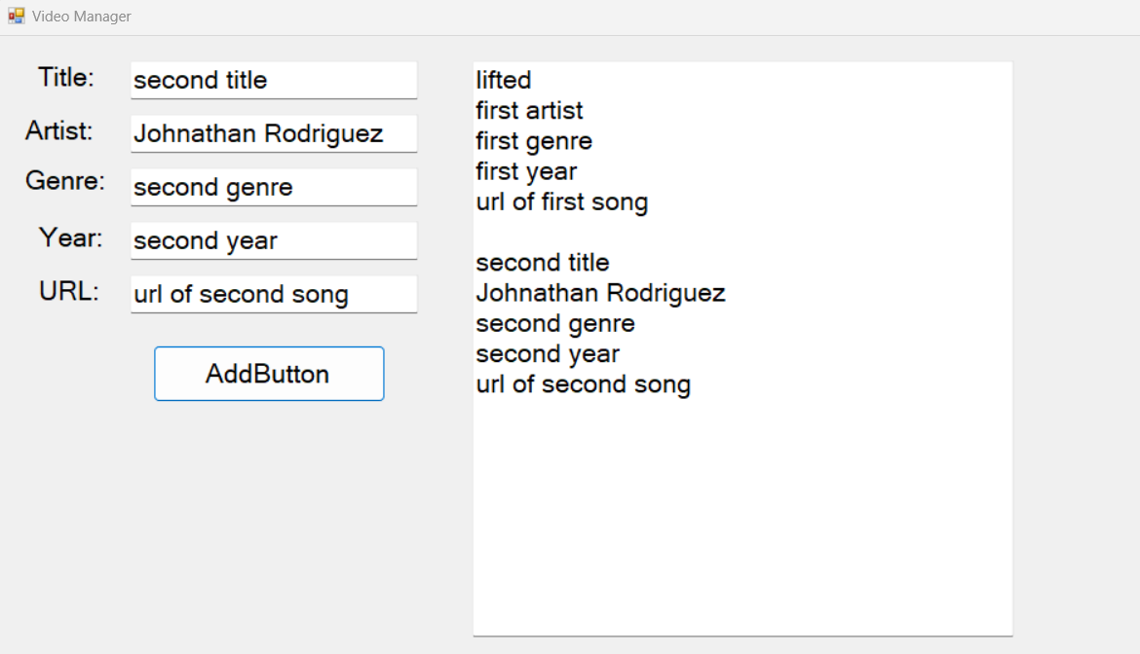

***Form code (only the code for the form, not program.cs):***

using System;

using System.Collections.Generic;

using System.ComponentModel;

using System.Data;

using System.Drawing;

using System.Linq;

using System.Text;

using System.Threading.Tasks;

using System.Windows.Forms;

namespace Rodriguez_CourseProject_Part1

{

public partial class titleLabel : Form

{

public titleLabel()

{

InitializeComponent();

}

private void artistLabel_Click(object sender, EventArgs e)

{

}

private void Addbutton_Click(object sender, EventArgs e)

{

StringBuilder sb = new StringBuilder(outputText.Text);

string nl = "\r\n";

sb.Append(titleText.Text);

sb.Append(nl);

sb.Append(artistText.Text);

sb.Append(nl);

sb.Append(genreText.Text);

sb.Append(nl);

sb.Append(yearText.Text);

sb.Append(nl);

sb.Append(urlText.Text);

sb.Append(nl);

sb.Append(nl);

outputText.Text = sb.ToString();

}

}

}